Review for test
A. Write the names of the heart parts next to each letter below.
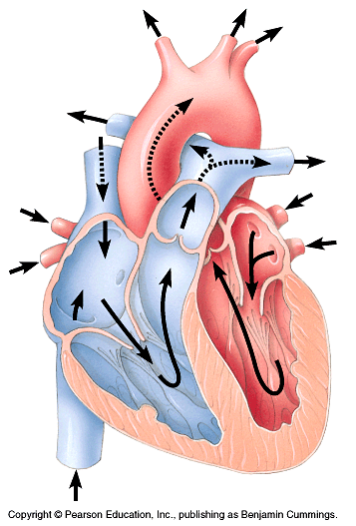
G.
F.
H.
IJ.
J.
K.
L.
C.
D.
E.
B.
A.

List the parts of the heart and explain each one’s significance. (ex/ septum – separates the right side of the heart from the left side)

A –

B –

C –

D-

E-

F-
G-

H-

I-

J-

K-

L-

Describe the following heart-related issues:

- Heart attack-

- Stroke-

- Artherosclerosis-

- Hypertension-

